
Mount Waverley Water Main Renewal Project
We are taking a break!!
The construction site will be shut down for the Christmas and New Year period, from Friday 22 December to Monday 8 January 2024.
No works will be carried out during this time however, the site will be monitored daily and the reduced 40km/h speed limit.
Lane closures within our work sites will remain in place to ensure the safety of all road users.
Works will recommence in the new year, from 7am, Monday 08 January 2024.
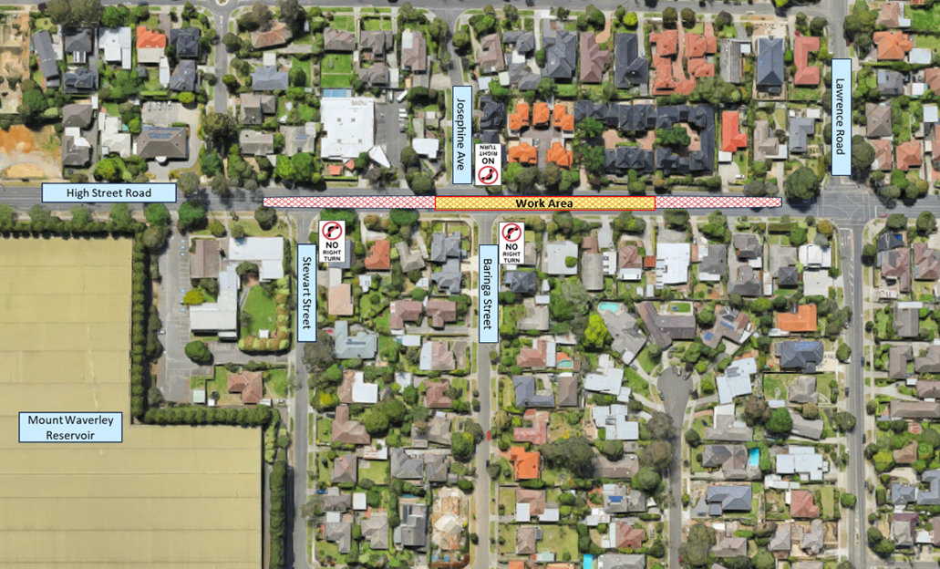
From our team, Merry Christmas and a Happy New Year 2024!
Figure 1: Map marking out the phases of works.

What to expect
Change in traffic: Traffic reduced to one lane in each direction on High Street Road. An increase in traffic on the roads surrounding High Street Road is anticipated. Please allow for extra travel time.
Detours: There will be no tight turn from the side roads next to our work sites. Follow detour signs.
Safety barriers will remain in place to keep the work site secure and road users safe.
Speed limit: Temporary speed limits of 40km/h will apply within the work site areas. Please exercise caution and drive carefully while driving past our work site.
Bus Service 734: To ensure the safety of residents, bus stops within the rolling work site will be temporarily closed. Early notice and direction will be provided. During construction you can plan ahead using the PTV app.

Community Corner -Open for business
The project team would like you to know that the traders who proudly operate along High Street Road and Blackburn Road intersection will remain open for business during our works.

The project team will ensure there is adequate signage, traffic management and signed detours for vehicles and pedestrians. This will ensure people can still access the community shopping precinct- buy local, support local.

Please contact your local businesses for more information on opening times.

Working hours
Works are scheduled to take place between Monday to Friday, 7am-6pm and Saturdays 7 am-1pm. This is in line with EPA Guidelines.
Prior notification will be provided if works are to occur outside standard times.



